Name:____________________________________________________ Per:_____ Date:_____________
Biomolecule Organizer
H. BIO
Macromolecule | Elements  Present | Monomer(s)Name and Shape | Polymer(s)  Name(s) and Shape | Functions
Carbohydrates |  | 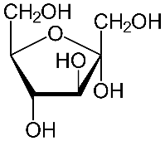 | 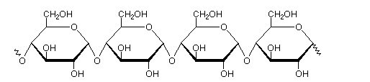
Lipids |  | Hint: There are TWO common building blocks in lipids | Name 2 Common Lipids Polymers:
Proteins |  | 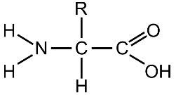 | 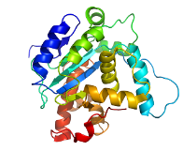  List the levels of folding:
Nucleic Acids |  | 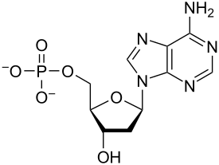 | 