Name:___________________________________ Unit:______________________ Date:___________ Pd:____
COURSE GUIDE – STATISTICAL ANALYSIS Honors Biology
** Make sure this is kept in a place that is always accessible *** KEEP FOR S2
Test | Use | Low Values | High Values | Additional Notes
Standard Deviation
Standard Error of the Mean
P Values
(Unpaired) T-Test
Paired
T-Test
Chi-Squared Test

Critical T Values | Critical Chi-Squared Values
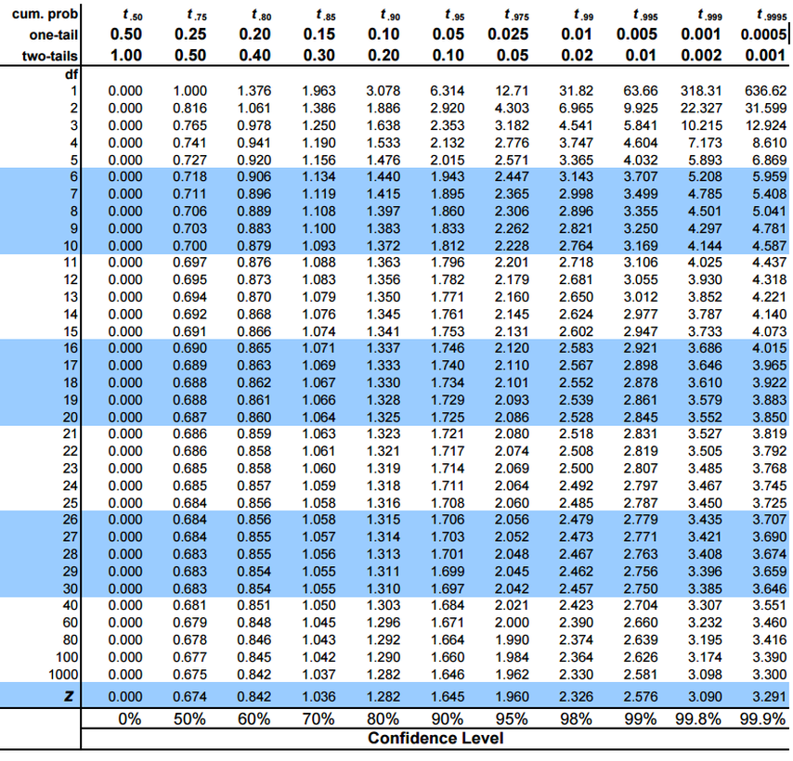 | 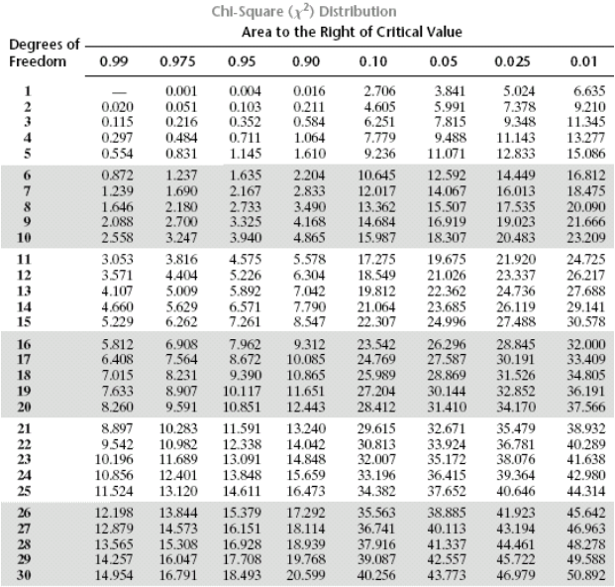
Conclusion Sentence Structure/Additional Notes

