Name:_____________________________________________________________________ Per:_____ Date:_____________
Notes – Control of Gene Expression
Honors Bio – Front side (p. 212-215) Back side (p.215-216)
A)  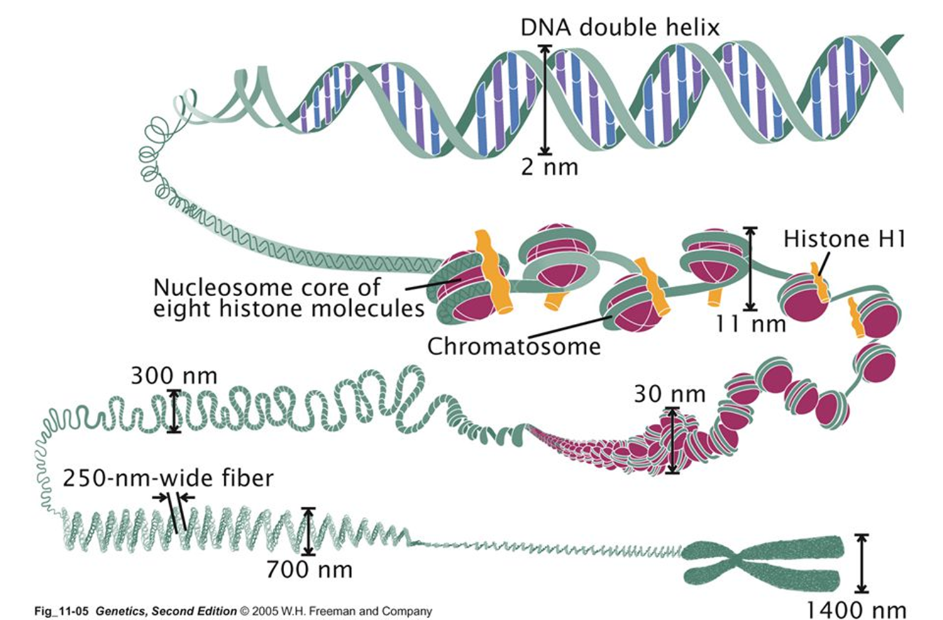 | D) | E)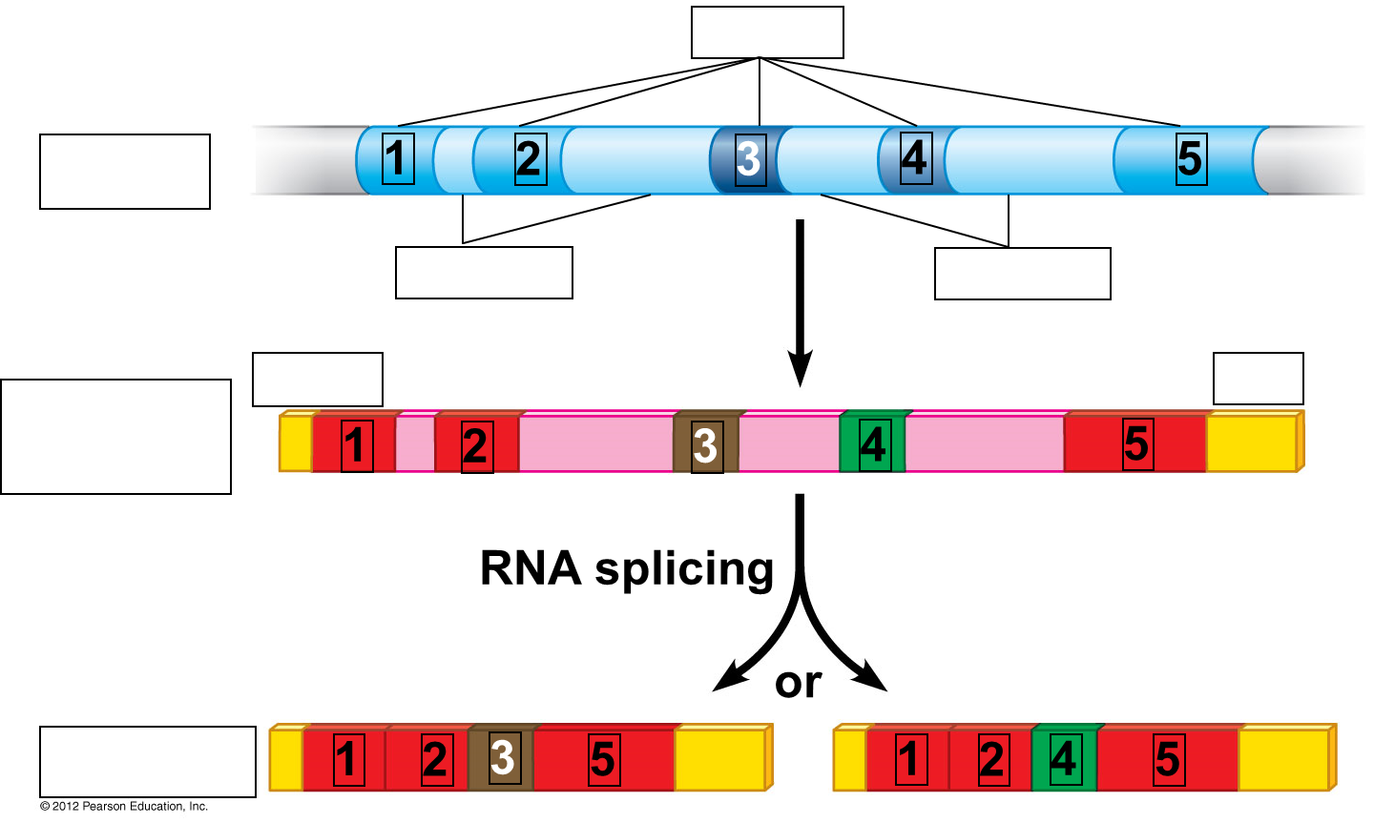
B) | D)
C)  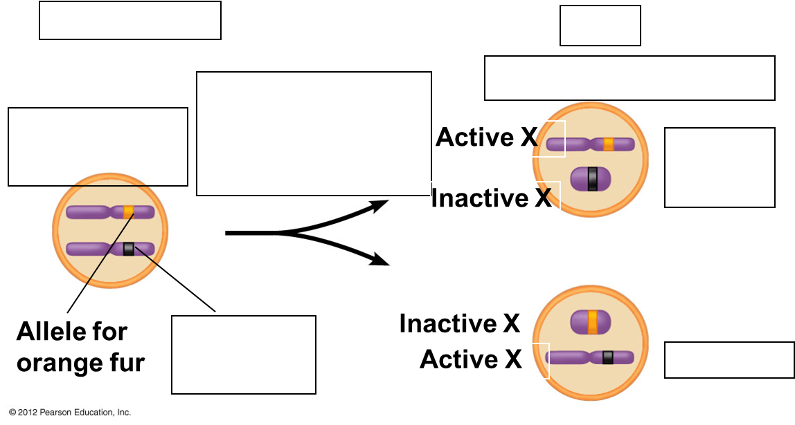 | D)

F) |  | G)
H) | I) |  | J)

