Notes - Digestive System Name:_________________________________ Date:__________ Pd:_____
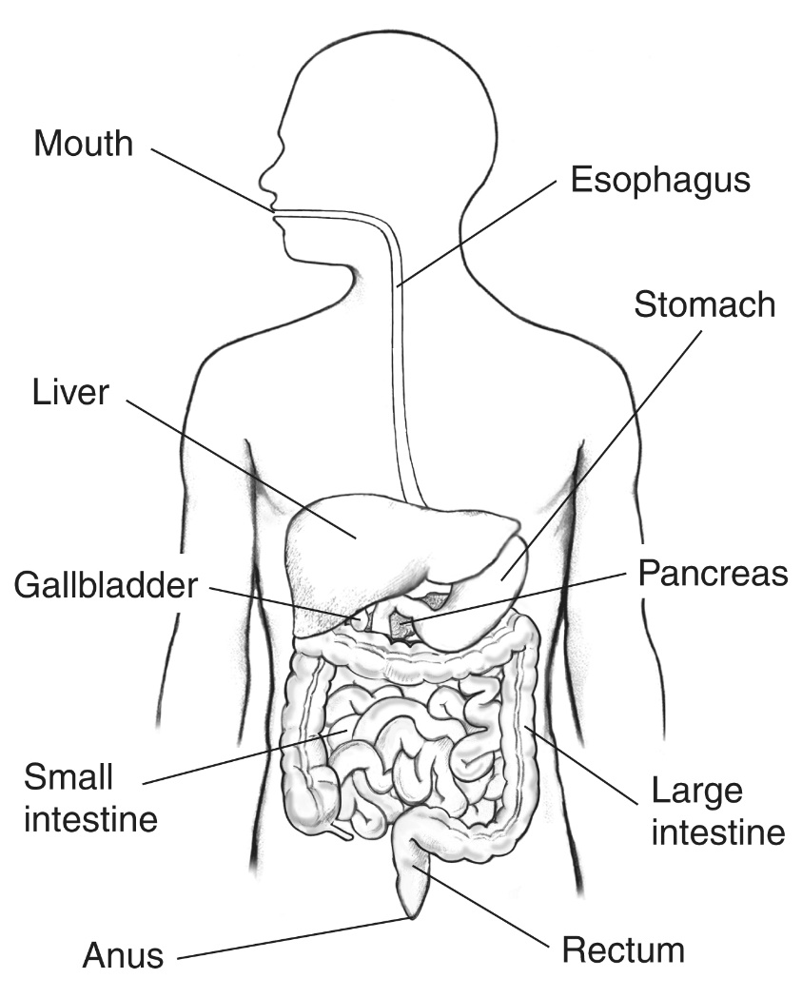
Digestive System Enzymes
Site | Enzyme(s) | Role in Digestion
Mouth
Stomach
Small Intestine
(from Pancreas)
Small Intestine
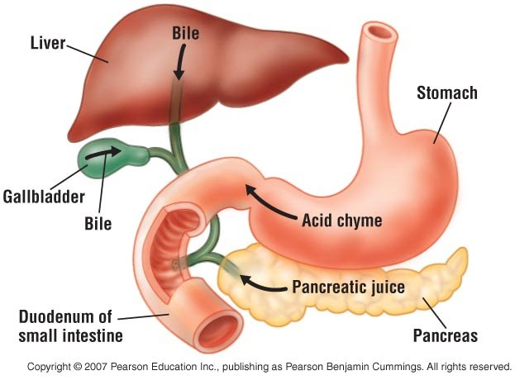
Part 2: Accessory organs involved in digestion.

Describe the function of each of the following organs. Include all secretions for each organ:
1.) Liver (describe emulsification in definition):
3.) Gall Bladder:

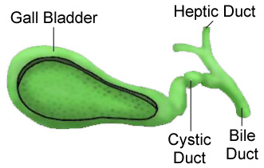
2.) Pancreas:

