Name: __________________________________________ Date: _______________ Period: _______ Unit: Human Body
The Inner Workings of the Kidneys
The diagram below represents blood entering and leaving a nephron. Some of the contents of the blood and the filtrate are indicated in the key.
- Area A shows the blood entering the kidney.
- Area B shows the blood after filtration.
- Area C shows the filtrate.
- Area D shows the blood after reabsorption.
- Area E shows the location of the formation of urine.

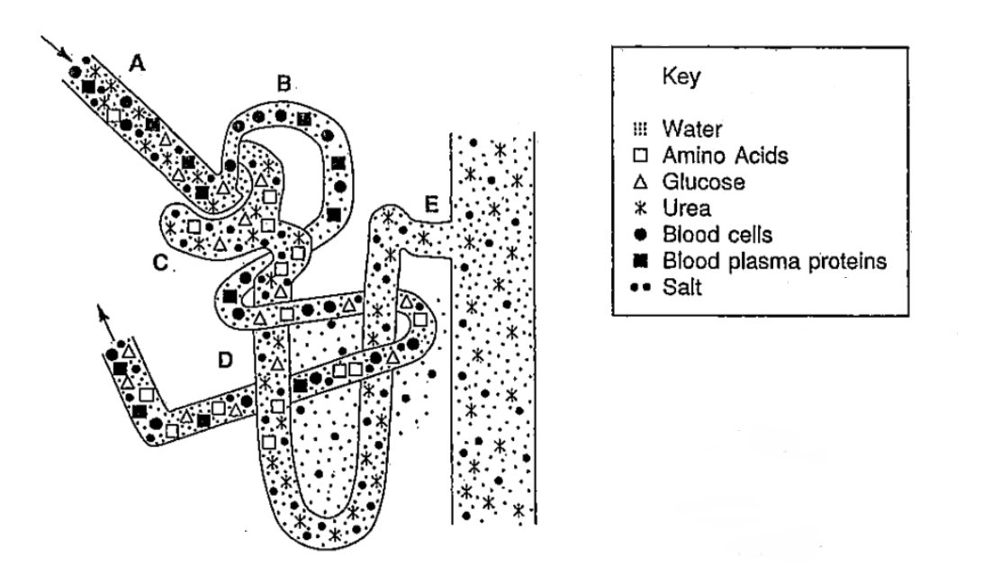
- The movement of materials from the glomerulus to Bowman’s Capsule is called filtration. What substances are found in the filtrate? _______________________________________________________________________
- What substances do not pass out of the blood? _________________________________________________
- Reabsorption of useful materials occurs in the tubules. What substances are reabsorbed into the blood by the tubules? _________________________________________________________________________________
- What substances are found in the urine? ______________________________________________________

Each of the diagrams below illustrates a collecting tubule containing the filtrate that forms urine. Answer the questions that follow.
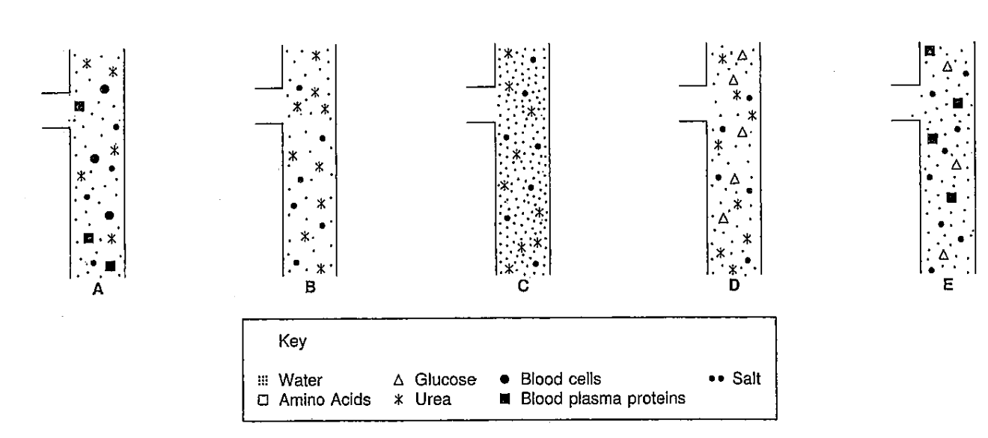
Reabsoption of water occurs as the filtrate passes through the collecting tubule. Antidiuretic hormone (ADH), released into the blood by the posterior pituitary gland, makes the collecting tubule more permeable to water. As the level of ADH in the blood increases, more water is released from the collecting tubule and enters the blood.
- Which diagram shows the collecting tubule under the influence of a high level of ADH? ___________________
- In terms of the water concentration, describe the urine as either concentrated or dilute. __________________
Caffeine inhibits the effect of ADH and is therefore considered a diuretic. A diuretic causes the production of a large volume of urine.
- Which diagram shows the effects of a high level of caffeine in the blood? ________________________
- In terms of water concentration, describe the urine as either concentrated or diluted. ___________________
Nephritis is an inflammation of the nephron, often caused by a bacterial infection. The infection may damage the glomerulus and Bowman’s capsule. Such damage may allow substances not normally found in the filtrate to pass through Bowman’s capsule.
- Which diagram shows the filtrate that may result from a case of nephritis? ______________________________
- Describe the contents of the urine. _______________________________________________________________
The tubule of the nephron is capable of reabsorbing from the filtrate a maximum of 375 mg of glucose per minute. If more glucose is present in the filtrate than can be reabsorbed, the glucose will remain in the filtrate. People with untreated diabetes mellitus may have a high level of glucose in the blood.
- Which diagram illustrates this condition? _________________________________________________________
- Describe the contents of the urine. _______________________________________________________________

