Name:____________________________________________________ Per:_____ Date:_____________
Labeling Structures of the Brain
Honors Bio
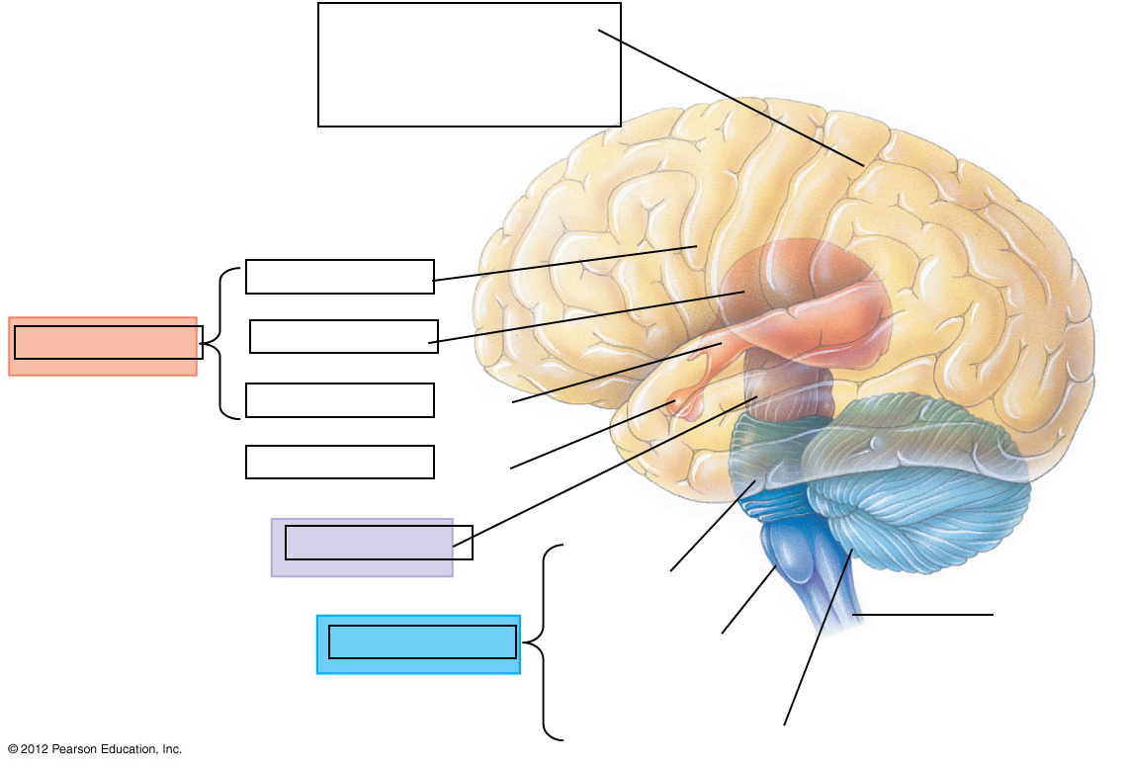

Use this page to Record the FUNCTIONS of all the parts from the diagram:

