Name:____________________________________________________ Per:_____ Date:_____________
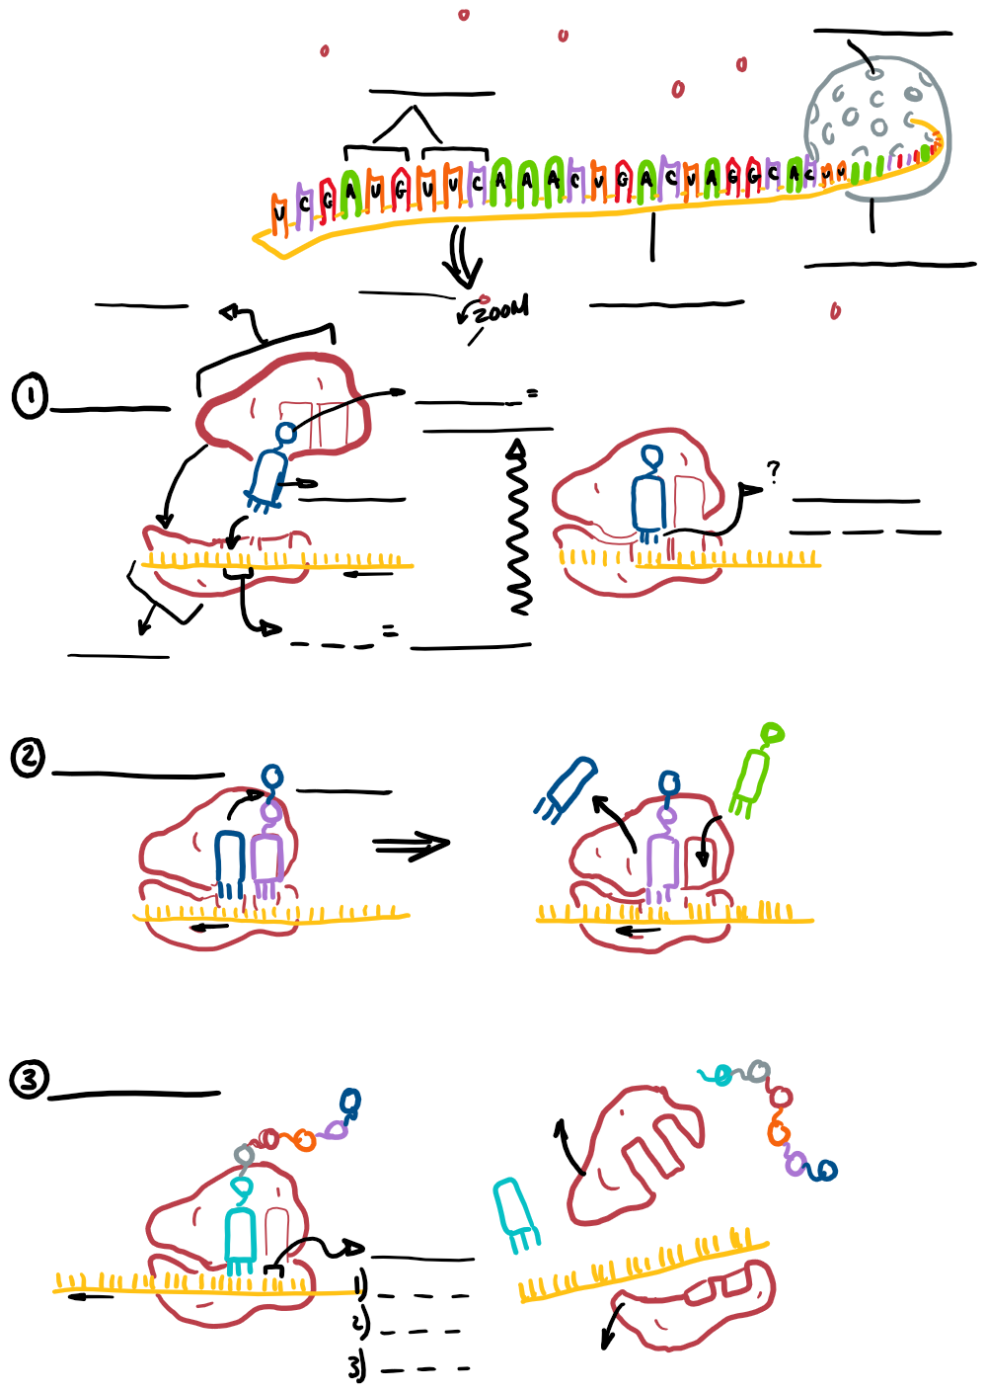
A closer look at TRANSLATION – Protein Synthesis
Honors Bio

