Name:___________________________________ Unit:_____________________________ Date:___________ Pd:____
Mini Lab – Mendel’s Observations Simulation
Honors Biology

Question:
What was Gregor Mendel’s “light-bulb” moment?

Overview:
In this lab you will perform many of the same genetic crosses as Gregor Mendel. You will study the heredity of four
pea plant characteristics and do parental (P) and first generation (F1) crosses.

Procedure:
- Go to https://www.newpathonline.com/free-curriculum-resources/virtual_lab/Mendel_s_Pea_Plant_Experiments/8/12,13,14/1850 OR click link in 6.1 assignments Select the parental (P) generation cross you would like to study.
- Count the number of each trait that you see in the first (F1) generation offspring and record your results. Then click the next button.
- To perform an F1 cross, click on the two offspring you would like to use as parents.
- Count the number of each trait that you see in the F2 generation offspring and record your results.
- Click on start over to repeat the procedure with the same parental generation cross or select a different cross.

Data and Observations:
Fill in the table below with the data collected from the genetic crosses.

Trait | # of Offspring  (F1 Gen.) | # of Offspring  (F2 Gen.) | Trait | # of Offspring  (F1 Gen.) | # of Offspring  (F2 Gen.)
Round Seed |  |  | Wrinkled Seed
Green Pod |  |  | Yellow Pod
Purple Flower |  |  | White Flower
Tall Plant |  |  | Short Plant
Sum
Average
%
(Avg. / 20)

Conclusion:

1. What pattern did you observe in the F1 offspring?_______________________________________________________
__________________________________________________________________________________________________

2. In general, what traits from the P Generation did you see in the F2 offspring?_________________________________
__________________________________________________________________________________________________

3. What percentages of each trait did you observe in the F2 offspring?_________________________________________
__________________________________________________________________________________________________
4. Complete the Punnett squares below for the parental cross and the F1 cross of the pod color trait.
Parental (P) cross |  |  |  | F1 cross

5. What fraction of each trait is present after the P cross?

Green Pod = _____ / 4 = _____% Yellow Pod = _____ / 4 = _____%

6. What fraction of each trait is present after the F1 cross?

Green Pod = _____ / 4 = _____% Yellow Pod = _____ / 4 = _____%

7. Complete the Punnett square below for the F1 cross by writing the correct letters in each box.

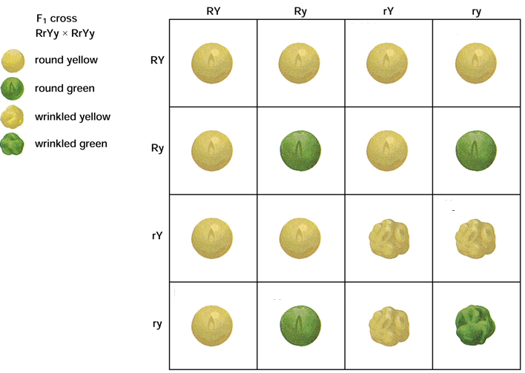

7. What makes this cross different from the crosses done during the investigation online? ________________________
__________________________________________________________________________________________________

8. What fraction of each trait is present after the F1 cross?
Round + Yellow = _____ / 16 Round + Green = _____ / 16
Wrinkled + Yellow = _____ / 16 Wrinkled + Green = _____ / 16

